** The Joint Chinese College Alumni Association of Southern USA**

***Leisure Learning Club 2019 Trip***

**10 Days Discover the Spectacular Bolivia & Lake Titicaca**

**January 30, 2019 – February 8, 2019**

**14 Days Bolivia & Lake Titicaca + Post Tour to Torres Del Paine**

**February 8, 2019 – February 12, 2019**

**Early Bird Bonus:**  For LLC members who complete their registration and postmarked by:

**5/15/18 Trip A - Bolivia & Titicaca - $300, Trip B - Bolivia & Titicaca + Torres Del Paine $500**

**6/15/18 Trip A - Bolivia & Titicaca - $200, Trip B - Bolivia & Titicaca + Torres Del Paine $300**

# Registration Deadline: 06/30/18 with Deposit, Registration/Liability Waiver Form and passport photocopy

Final Payment Due Date: 07/15/18 Limited Space, first come first serve

**Kick off Seminar – 5/6/18, 2:00p.m. at Chinese Culture Center**

  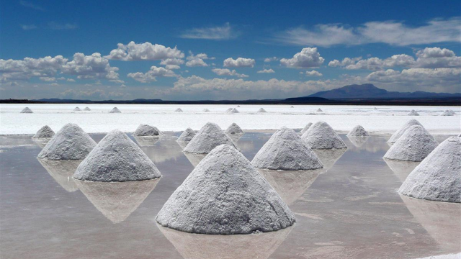 

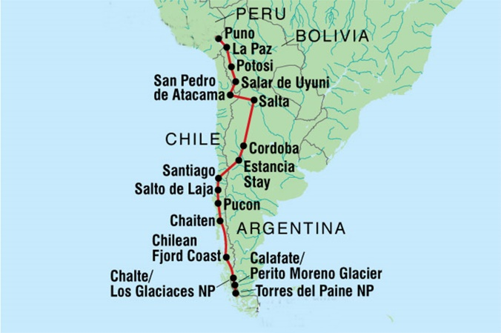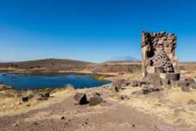



**Torres Del Paine Post Tour**

**February 7, 2018-February 12, 2019**

   

