##### Joint Chinese College Alumni Association

美南中國大專院校聯合校友會

**Presents**

### **2018 Annual Conference for Professionals**

### **Saturday, November 17, 10am – 5pm at**

**Chinese Culture Center** 休士頓華僑文教服務中心

**10303 Westoffice Dr, Houston, TX 77042**

  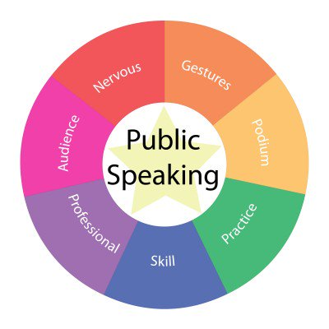         

**Professional Career Advancement**

**10am-12noon**

**Keynote Speaker**

**Ms. Tara Wanner, BP Energy Company CIO**

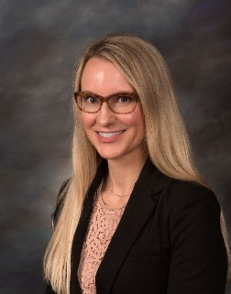

* **Personal Characteristics for Success in the organization**
* **Self-Advocacy in an unfamiliar business world**
* **The next growth opportunity**

**Lunch 12:00-1:00p.m.**



**Conference Fee $10 per person; students with valid IDs are free; Lunch included.**

**Presentation in Chinese or English. No translator.**

**Register by:**

**Google Form link is** [**https://goo.gl/forms/GvzMy6kvHEEYLSG32**](https://goo.gl/forms/GvzMy6kvHEEYLSG32)

**or**

**Write check to JCCAA & mail with registration form to: Linda Young, 3806 Elkins Rd, Sugarland, TX 77479**

**Registration Deadline: Saturday, November 10, 2018**

**Contact: Linda Young 713-340-8115, Janet Chung 832-818-1848, Leif Hsieh 832-589-7078, James Hsu 281-208-9230**